**Windows**

**Installation**

BASIC COMPUTER USAGE

**OBJECTIVES FOR TODAY** 

* Be able to identify **Windows Editions**
* Understand how to **setup Windows** on computer
* Understand about **Device Driver**
* Be able to perform **Windows Update**

ENGAGE



5

MIN

**What is Windows**

**Edition**

**?**



**Windows Update**

**Things you need to know before setup OS**

Understanding Windows 10 Editions

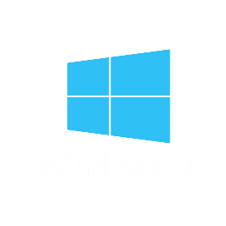

Windows 10 Home, Enterprise, Professional

Understanding Windows Licenses

How to buy license, license pricing, checking license

System Requirement for Windows 10

RAM, Hard disk space, CPU,…

Get to know Administrator User

Managing user, Administrator, Root

# Understanding Windows 10 Editions



Commonly, there are *5 editions* of Windows 10:

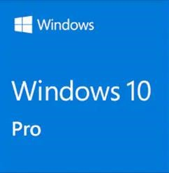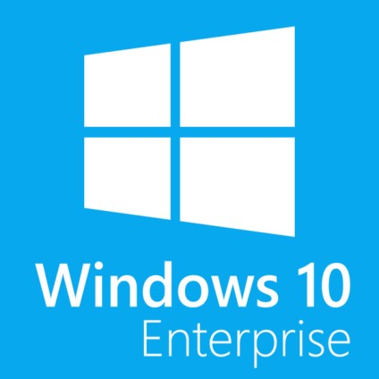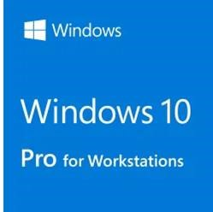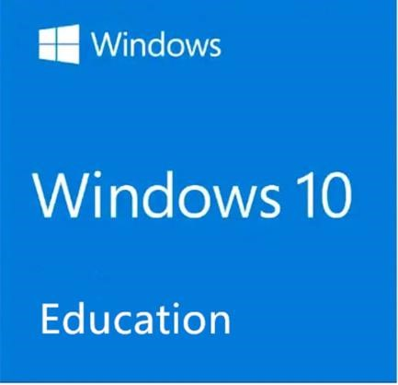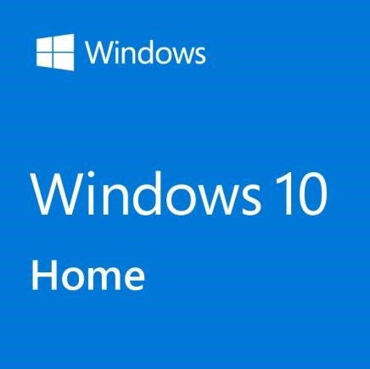

|  |  |  |  |  |
| --- | --- | --- | --- | --- |
| Designed for  general users primarily  **accessing**  **Windows at Home** | A solid foundation for **every business** | Designed for people with **advanced**  **workloads** or data needs. | The foundation for businesses  and enterprises who need  **security,**  **reliability and management controls** | For **organizations** with advanced security and  management needs |

# Understanding Windows Licenses



Microsoft Windows has two different type of License

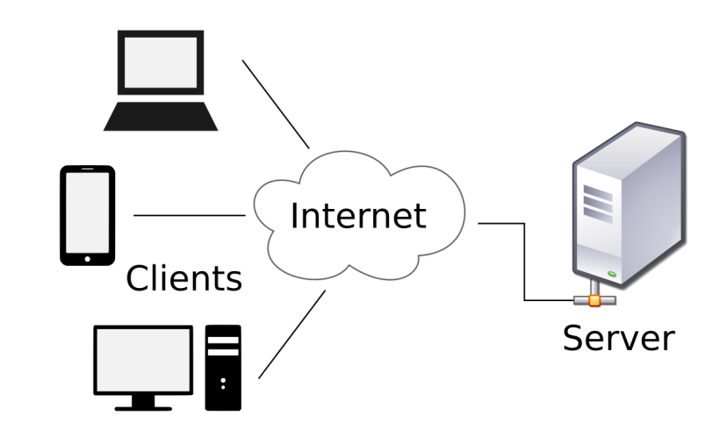

▪ Windows Client License

▪ Windows Server License

## Windows Client License

There are three type of Windows Client Licenses:

* Retail License
* OEM License
* Volume License

# Understanding Windows Licenses



**Retail:** This license is called Full Packaged Product (FPP), commonly known as a “boxed copy” This license type has one license key (product key). You can use this key on another computer as long as you deactivate the old device.



**OEM (Original Equipment Manufacturer):** Provided by the system manufacturer.



This license type cannot use it on another computer. Also, if this Windows version is Windows 8 or Windows 10, the license key is embedded in UEFI/BIOS firmware chip.

**Volume:** This type of license is an institutional license type, such as schools and government offices. These non-resale licenses provide common use. This means that Windows is activated on multiple computers with a single license key.



# System Requirement for Windows 10



System requirement for installing windows 10:

|  |  |
| --- | --- |
| Processor: | 1 gigahertz (GHz) or faster processor |
| RAM: | 2GB for 32-bit OS or 4GB for 64-bit OS |
| Hard drive space: | 20GB for 32-bit OS 32GB for 64-bit OS |

# Get to know User Account



There are two type of user account on Windows 10 including **Administrator and**

**Standard user**. Each one offering different set of permission to device and applications.

* **Administrator user** has complete system control permission, which means that users can change settings globally, install apps, execute tasks, and perform pretty much anything.
* **Standard user** account type is more restrictive. Users with the standard account can work with apps, but they can't install new applications. They can change settings, but only those that won't affect other accounts.

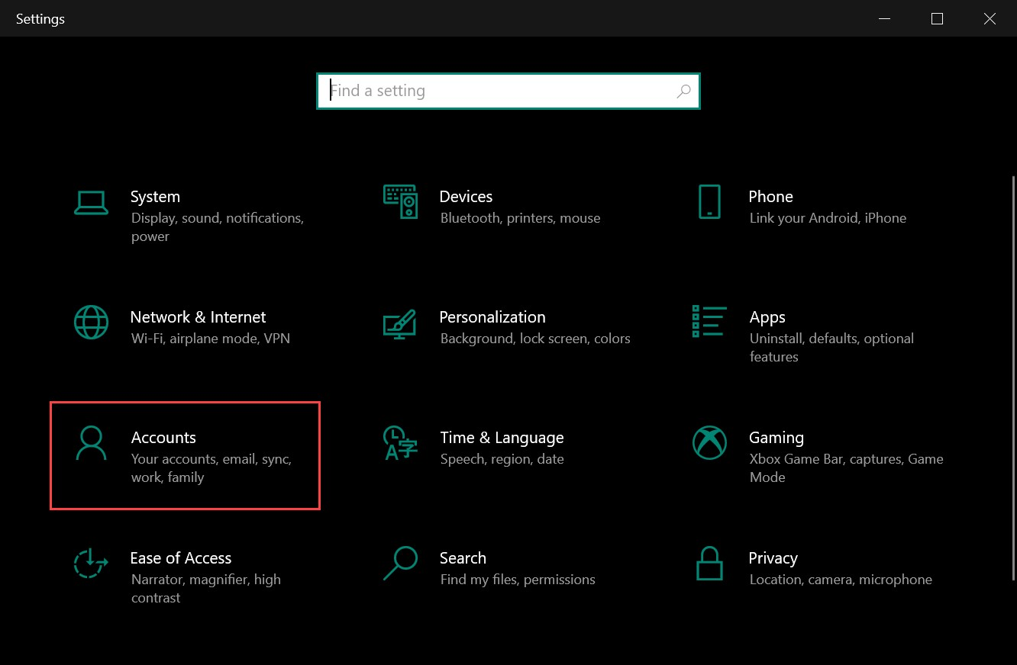

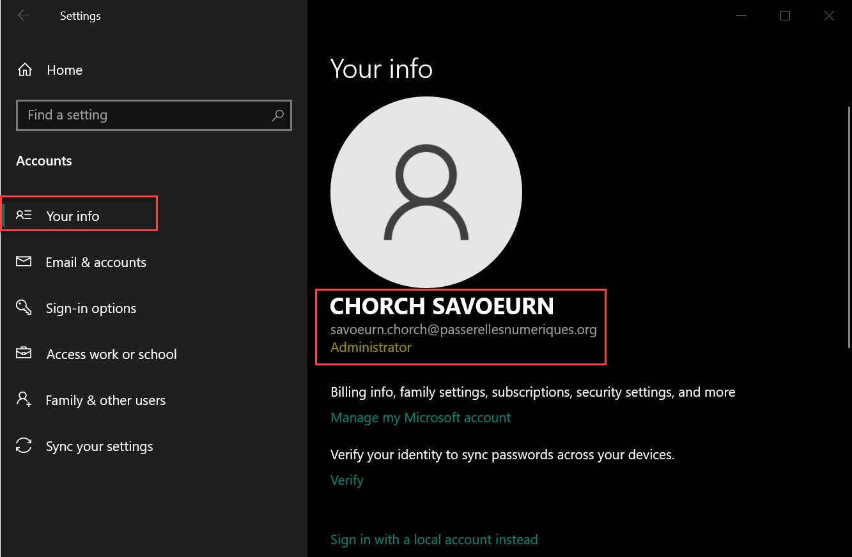

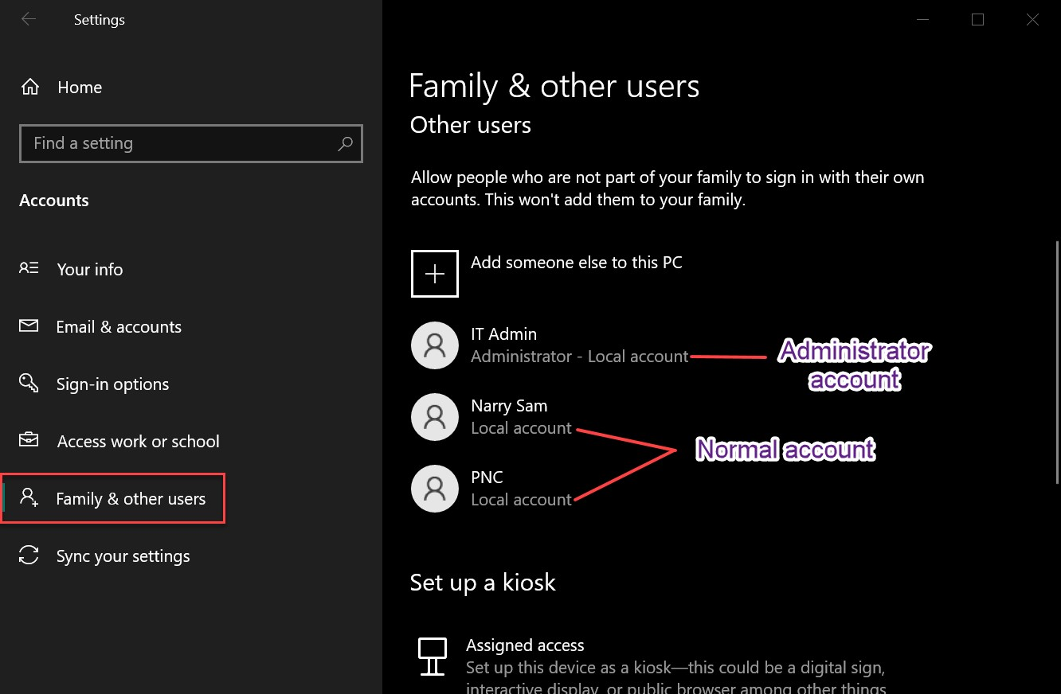

# Understanding File System

* In a computer, a **file system** (sometimes written *filesystem*) is the way in which files are named and where they are placed logically for storage and retrieval.
* There are many types of file system such as EXT2, EXT3, EXT4, FAT, NTFS….
* There are some file systems that *Windows support natively*:

▪ FAT (out of date)

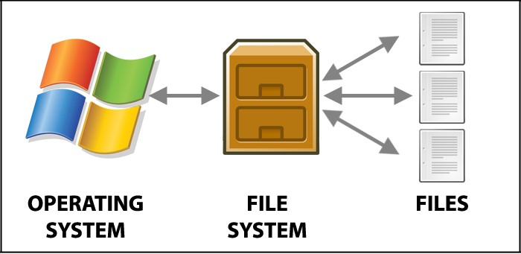▪ FAT32

▪ exFAT

▪ NTFS

**Understand how to install Windows on a Computer**

**Materials needed for setup new OS on a laptop/desktop:**

* + Bootable media (USB Flash, CD, DVD…)

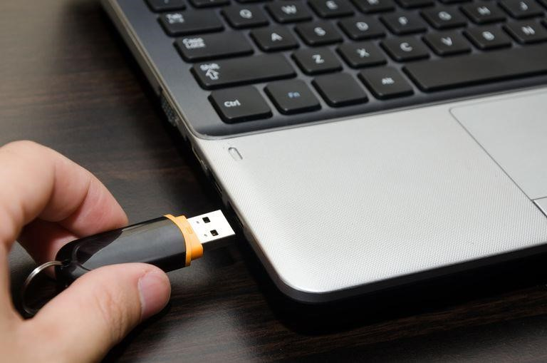

* + Laptop/desktop

**Step to setup new OS on computer:**

* 1. Connect bootable media to computer
  2. Change boot option on computer to boot from bootable media instead of HDD
  3. After that start to install a new OS to computer hard disk drive

## Introduction to Device Driver

* After OS installation is completed, there can still be devices not working. Sometimes you cannot access the network, print documents, do your daily tasks and work for your specific needs …
* If you want your computer run smoothly and be useful for you, you need to check driver on your computer.

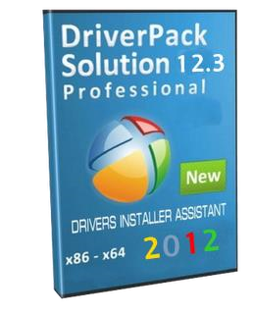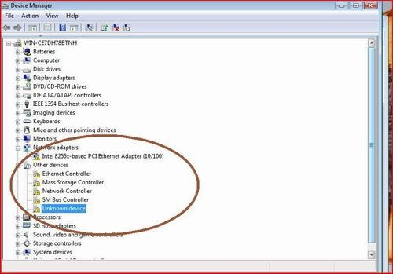

## The Meaning of Driver

* **Drivers** are software that enable one or more hardware devices to communicate with the computer's Operating System.
* For Windows OS, many Drivers are already part of the OS, but some are still missing. You can see missing drivers in **Device Manager**

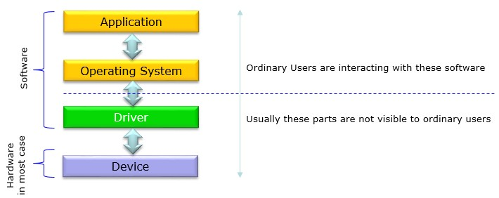

## Check Location of Driver

Device Manager is a [Control](https://en.wikipedia.org/wiki/Control_Panel_(Windows)) [Panel](https://en.wikipedia.org/wiki/Control_Panel_(Windows)) in [Microsoft](https://en.wikipedia.org/wiki/Microsoft_Windows) [Windows](https://en.wikipedia.org/wiki/Microsoft_Windows) operating systems. It allows users to view and control the hardware attached to the computer.

Access Device Manager: RUN → devmgmt.msc

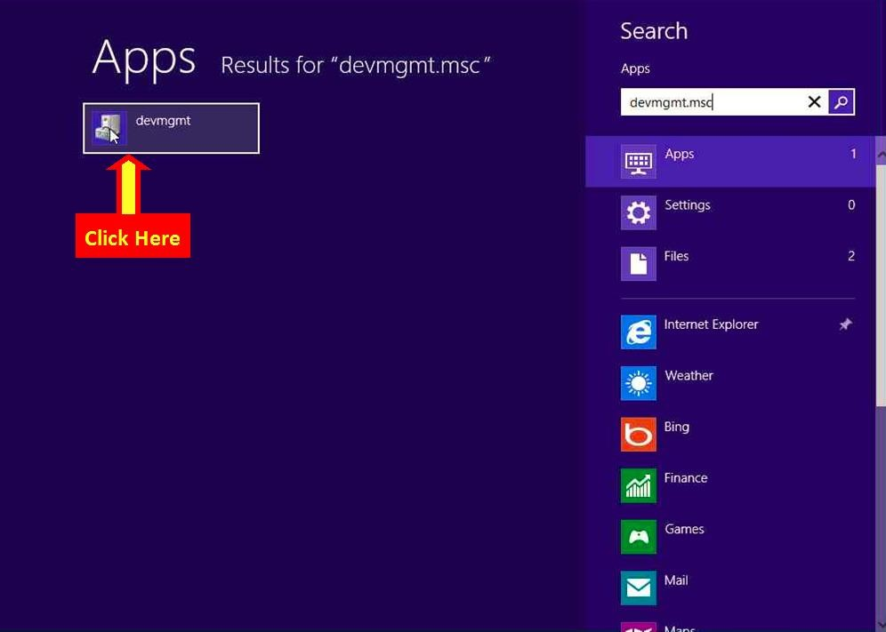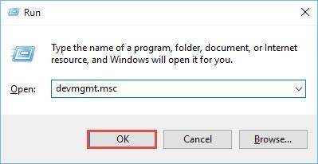

## Check Location of Driver

All the driver display on device manager

**HOW TO INSTALL**

**DEVICE DRIVERS ?**

**Method Driver Installation**

**1. Install driver by using update on device manager:**

* In the Device Manager, click on the device you want to update.
* Right-click the device and click **Properties**.
* In the Properties window, click the **Driver** tab.
* Click the **Update Driver** button.

## Method Driver Installation

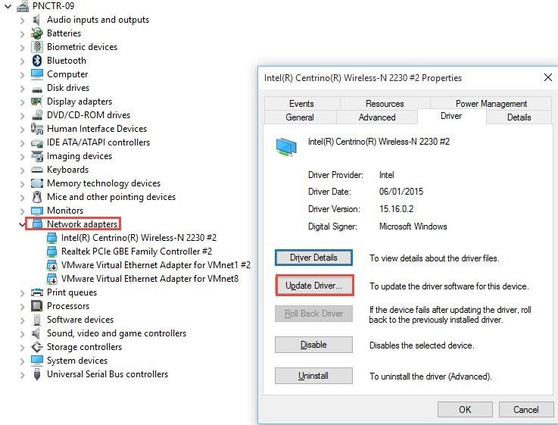

Right click on device driver that you want to update

**Method Driver Installation**

**2. Install driver by download driver from manufacturer website**

✓Step 1: you need the model number for your laptop and type of OS

✓Step 2: identify the hardware manufacturer and find their support website online

✓Step 3: go to the hardware manufacturer’s site and download section

✓Step 4: search the download section for the correct driver that you need

✓Step 5: download the needed driver

How to check serial number: RUN -> cmd -> **wmic bios get serialnumber**

### How to make sure driver installed

* All the driver, if you’re want to make sure that installed or not you can verify on the device manager. By run➔ devmgmt.msc, and you check all the device and all components.

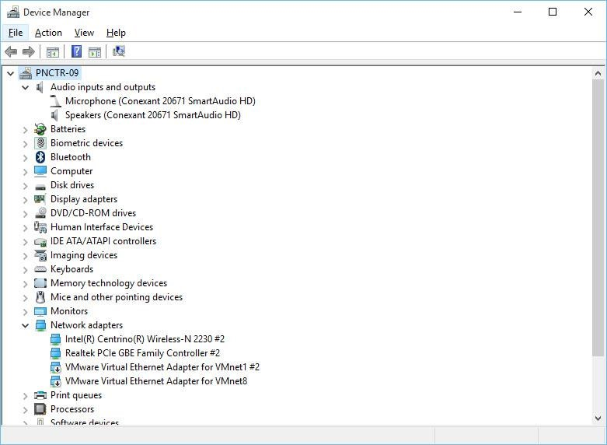

25

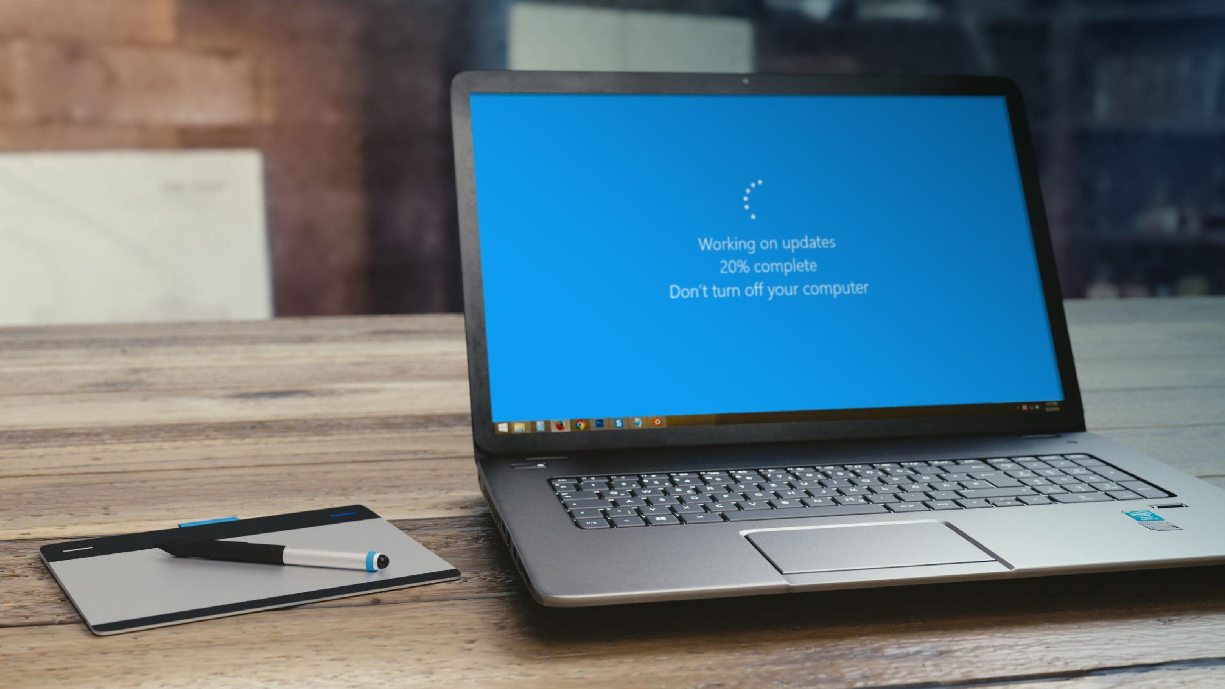

**What is Windows Update?**



**Why update?**



**What is windows update?**

**Windows Update** is a Microsoft Service that's used to provide updates for the Windows operating system and other Microsoft software.

➢**Note:** Windows Update does not update non-Microsoft software.

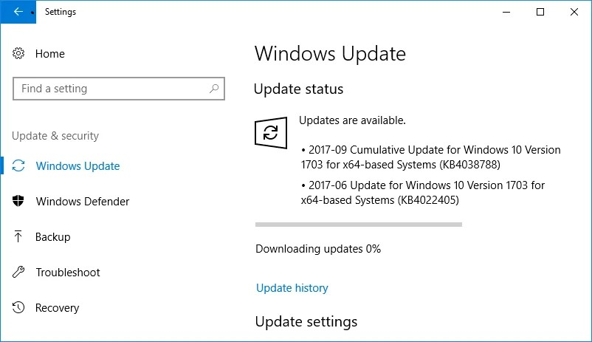

**Why need to update your windows?**

**Updates are additions to software that can help to:** o Prevent or fix problems o Improve how your computer works o Enhance your computing experience



o Updates often include feature enhancements and security updates to protect Windows from malware and malicious attacks.



**Update window using windows update**

* How you access Windows Update depends on which Windows operating system you're using:
* Windows update is part of System Settings, available from the Start Menu

Click on **Start** button, and then go to **Settings** > **Update & Security** > **Windows Update**

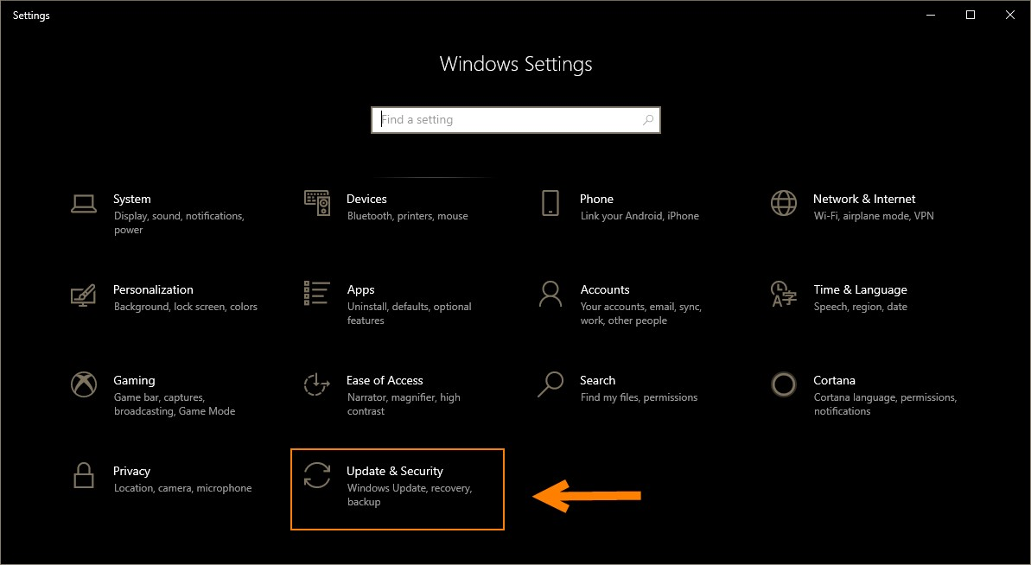

**Update window using windows update**

# Update window using windows update

